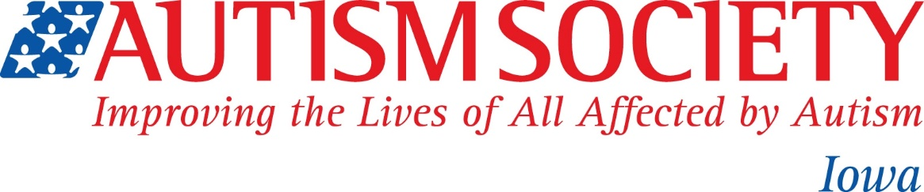

Autism Society of Iowa Press Release

September 24, 2019 Contact: Kris Steinmetz
For Immediate Release Autism Society of Iowa
Autism50ia@aol.com
515-327-9075

The Autism Society of Iowa has received a $4843.00 grant from Variety – The Children’s Charity to fund the Splash for Autism Events in Iowa.

The Autism Society of Iowa is a nonprofit organization serving Iowa to advocate, support and inform those with autism, their families and their communities.

The Variety grant will be used to rent pools to provide a safe, sensory friendly pool event for those with autism who enjoy water, along with their families and care givers, but who cannot attend a public pool when it is open to the public. “The Splash for Autism Events are very popular, and this grant allows us to expand this program and to offer it year-round. The Autism Society of Iowa is very grateful to Variety – The Children’s Charity to help make this possible.” Kris Steinmetz, Executive Director.

Variety, the Children’s Charity is dedicated to improving the lives of children who are at-risk, underprivileged, critically ill or living with special needs. Grant funding is provided to programs and initiatives that directly impact the well-being of children. For more information on Variety grants and programs please visit varietyiowa.com

####

