Pool Tournament to Benefit the Autism Society of Iowa
At
9 Ball Singles Tournament, Race to 3
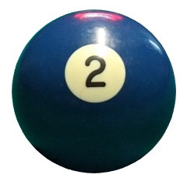
Date: April 18, 2021
Address: 7460 Hickman Rd
1:00 – Registration and Rules Meeting
2:00 – Play Begins
$10.00 Registration Fee, $15.00 for T-shirt

Winner Receives ½ of Registration Fee
Questions? Please call or text Jeremy Davis at 712-269-8889

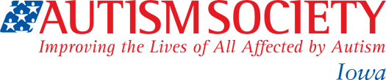
$1.00 from every blue signature drink sold benefits:

