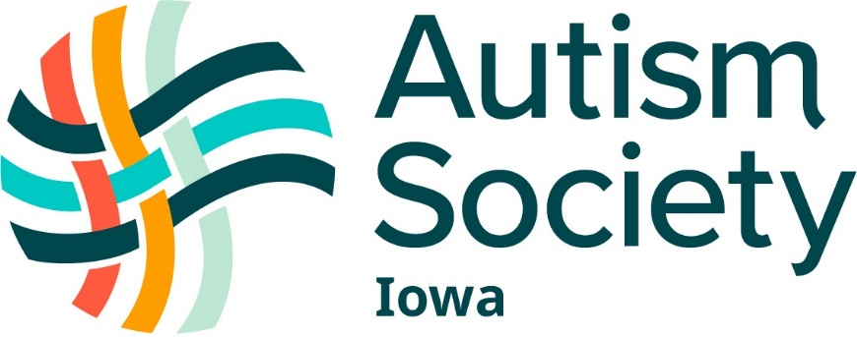

Transitioning, Vocational Services, and Disability Services at Iowa Colleges for the Student with Autism
Created by the Autism Society of Iowa
March 2022
Transitioning from High School to College
The following links are provided to assist students with disabilities in their transition from high
school to college:
Transitioning_HS-College_ComparisonChart.pub (niacc.edu)
Students with Disabilities Preparing for Postsecondary Education: Know Your Rights and
Responsibilities
http://www2.ed.gov/about/offices/list/ocr/transition.html
Preparing for College - An Online Tutorial: A Guide for High School Students and Their
Advocates. Learn how to advocate, what your learning style is and what accommodations you
will need, finding an academic area to study, and financial aid resources.
http://www.washington.edu/doit/Brochures/Academics/cprep.html

Vocational Training
Des Moines Area Community College STRIVE
STRIVE - Selected Training Received in Vocational Education (dmacc.edu)
Iowa Central Community College
Iowa Central: Career Connections
Iowa Lakes Community College SAVE Program
Special Needs Services - Iowa Lakes Community College
Kirkwood Community College VITAL Program
Vocational Individualized Training and Learning Services (VITAL) | Kirkwood Community College | Cedar Rapids, Iowa
Vocational Rehabilitation
http://www.ivrs.iowa.gov/Transition/Transitionhome.htm
Job Corps
www.recruiting.jobcorps.gov or 1-800-5627 to reach an admissions counselor

Disability Services at State Universities in Iowa
Iowa State University, Ames:
Welcome to Student Accessibility Services | Student Accessibility Services | Iowa State University (iastate.edu)
University of Iowa
Student Disability Services | The University of Iowa (uiowa.edu)
Support for Students: Neurodiversity and Autism Spectrum Disorder | Student Disability Services - The University of Iowa (uiowa.edu)
UI REACH | College of Education - The University of Iowa (uiowa.edu)
University of Northern Iowa
Accessibility Resources at UNI | University of Northern Iowa

Disability Services at Community Colleges
Des Moines Area Community Colleges
Disability Services Office (dmacc.edu)
STRIVE - Selected Training Received in Vocational Education (dmacc.edu)
Eastern Iowa Community College
Students with Disabilities (eicc.edu)
Hawkeye Community College, Waterloo
https://www.hawkeyecollege.edu/students/services/student-disability-services/default.aspx
Indian Hills Community College
Indian Hills Community College | Disability Services
Iowa Central Community College, Fort Dodge
Iowa Central Academic Resource Center (ARC): Accomodation Services
Iowa Central: Career Connections
Iowa Lakes Community Colleges
Accommodations & Disabilities Services - Iowa Lakes Community College
Special Needs Services - Iowa Lakes Community College
Iowa Valley Community Colleges
Disability Services - Ellsworth Community College (iavalley.edu)
Accommodations for Disabilities - Marshalltown Community College (iavalley.edu)
Iowa Western Community College
TRIO/Student Support Services - Iowa Western Community College (iwcc.edu)
Kirkwood Community College
Accommodation Services | Kirkwood Community College | Cedar Rapids, Iowa
Autism Program @ Kirkwood (ASK) | Kirkwood Community College | Cedar Rapids, Iowa
Vocational Individualized Training and Learning Services (VITAL) | Kirkwood Community College | Cedar Rapids, Iowa
North Iowa Community College
Disability Services - North Iowa Area Community College (niacc.edu)
Northeast Iowa Community Colleges
Accessibility Services - Northeast Iowa Community College (nicc.edu)
Northwest Iowa Community College
Academic Support - Northwest Iowa Community College (nwicc.edu)
Southeastern Community Colleges
Southeastern | Accommodation Services (scciowa.edu)
Southwestern Iowa Community College
Disability Support Services (swcciowa.edu)
Western Iowa Technical Community College
Disabilities Services - Western Iowa Tech Community College (witcc.edu)

Disability Services at Private Colleges and Universities
Briar Cliff University
Student Support Services | Briar Cliff University
Buena Vista University
Disability Services | Buena Vista University (bvu.edu)
Central College
Our Services – Campus Life (central.edu)
Clarke University
Accommodation Services - Clarke University
Coe College
Office of Accessibility Services | Coe College
Cornell College
Disability Services & Resources | Cornell College
Dordt University
Support Services For Students With Disabilities | Dordt University
Drake University
Disability Services | Drake University
Graceland University
Graceland University Student Life: Student Disability Services | Graceland University
Grandview University
Disability Services | Grand View University
Grinnell College
Accessibility and Disability Resources | Grinnell College
Iowa Wesleyen University
Steven and Jill Howe Student Success Center - Iowa Wesleyan University (iw.edu)
Loras
Academic Accommodations | Disability Resource Cultural Center | Loras
ARCH Program
Lynch Learning Center: ARCH Program | Academics | Loras College
Luther College
Disability Services | Luther College
Morningside University
Disability Services - HJF Learning Center (morningside.edu)
Mount Mercy University
Disability Services (mtmercy.edu)
Northwestern University
Accommodations for disabilities | Northwestern College in Iowa (nwciowa.edu)
Northwestern NEXT Program
Northwestern Next | Northwestern College in Iowa (nwciowa.edu)
St. Ambrose University
Accessibility Resource Center (sau.edu)
Simpson College
Understanding College Accessibility | Simpson College
University of Dubuque
Disability Services (dbq.edu)
Upper Iowa University
Student Accessibility Services | Upper Iowa University (uiu.edu)
Waldorf College
Academic Achievement Center | Waldorf University
Wartburg College
Accessibility and Disability Services - Wartburg College
William Penn University
Student Success Center - William Penn University (wmpenn.edu)

